**Chapter 3 Analysis and planning**

3.1 Introduction

The analysis phase is the most crucial phase of any project. The quality of the analysis can make or break a project. Artificial intelligence presents challenges due the complexity involved in getting the balance between too much and not enough. Planning such a task is matter of finding what we really need and we don’t.

We may design systems which can process an extremely wide variety of inputs, but we cannot actively ensure that the AI will respond to it in the way we want it to. It may present us an output which was intended to be for another input, or it may not be able to process it due to the load caused by the heavy processing on the interpreter. We have to plan for such a scenario too. Thus, the challenge is not just of input handling or building features, but of efficiency as well.

We did this phase slowly so we be could be thorough with all our requirements and plans. A slow approach also allowed us to anticipate risks. Planning phase is probably the best time to plan for risks and avoid them altogether. Being careful in the planning phase allows us to put less effort into the risk mitigation, risk monitoring and risk management plan.

3.2 Product Backlog or Sprint backlog

The backlog of the project is given as follows:

To do

* Obtain insurance data
* Build an insurance selector
* Make GUI for fringe features
* Add a hospital finding feature
* Add a symptom matching feature
* Add an archiving feature
* Make a checklist database for users
* Obtain a fitness plan database
* Obtain global data for patients to compare with

Ongoing

* Information catalogue building
* Dataset training
* GUI building
* Procurement of more medical data for higher accuracy

Done

* Analysis
* Design
* Modelling
* Literature survey
* Budgeting and scheduling
* Feasibility analysis

3.3 Project planning (Resources, Tools used, etc.)

IT projects require resources in terms of money, time, human resources, infrastructure and technology, both hardware and software. Resources are not just a mean, but also an approximation of constraints.

Project planning is essential to managing the scope, schedule and budget of the project. For this, we used tools such as MS Excel, MS PowerPoint, online MS project as well as various modelling tools, such as draw.io.

Stakeholder perspective is crucial to the success of this project. Part of the reason is that medical diagnosis is a highly sensitive field, and even the slightest of errors, which are evidently unavoidable in even the most sophisticated software, can lead to the patient’s condition worsening. Thus, we made it a necessity to search for user consensus before we planned for features to be built in our project. This was done by researching search interest on search engines, visiting forums pertaining to machine learning, artificial intelligence, healthcare as well as wearable technology.

We divided our project into various phases and sub-phases, and allocated date ranges from a week to 3 weeks to every sub-phase. This was done using the timeline chart feature of online MS project. We then used a Gannt chart to model schedule dependencies and fine tune the scheduling. The Gantt chart was created using the Gantt chart feature available in MS Excel. Using these two, we further planned our sub-phases.

The modelling included charts and diagrams such as UML diagram, GUI modelling, dependencies and other diagrams. These were done using free tools like draw.io. Drawing these models helped to incisively assess our requirements and features.

3.4 Scheduling (Time line chart or Gantt chart) according to sprint backlog

|  |  |  |
| --- | --- | --- |
| **Task** | **Duration** | **No. of days** |
| Project title finalisation | 9/07/2018 - 13/07/2018 | 1 |
| Literature survey | 16/07/2018 - 27/07/2018 | 3 |
| Business case | 30/07/2018 - 3/08/2018 | 1 |
| Project charter | 6/08/2018 - 10/08/2018 | 1 |
| Requirement gathering | 13/08/2018 - 17/08/2018 | 1 |
| Security planning | 20/08/2018 - 24/08/2018 | 1 |
| Legal planning and user survey | 27/08/2018 - 31/08/2018 | 1 |
| Implementation and testing of basic functionality | 3/09/2018 - 14/09/2018 | 3 |
| Implementation and testing of GUI | 17/09/2018 - 21/09/2018 | 1 |
| Implementation and testing of machine learning functionality | 24/09/2018 - 5/10/2018 | 3 |

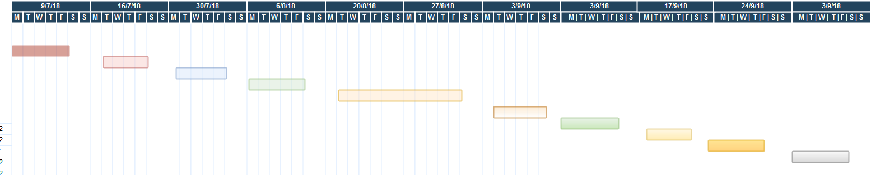

Gantt Chart

|  |  |  |
| --- | --- | --- |
| **Task** | **Duration** | **No. of days** |
| Project title finalisation | 9/07/2018 - 13/07/2018 | 1 |
| Literature survey | 16/07/2018 - 27/07/2018 | 3 |
| Business case | 30/07/2018 - 3/08/2018 | 1 |
| Project charter | 6/08/2018 - 10/08/2018 | 1 |
| Requirement gathering | 13/08/2018 - 17/08/2018 | 1 |
| Security planning | 20/08/2018 - 24/08/2018 | 1 |
| Legal planning and user survey | 27/08/2018 - 31/08/2018 | 1 |
| Implementation and testing of basic functionality | 3/09/2018 - 14/09/2018 | 3 |
| Implementation and testing of GUI | 17/09/2018 - 21/09/2018 | 1 |
| Implementation and testing of machine learning functionality | 24/09/2018 - 5/10/2018 | 3 |
| Synopsis and report | 8/10/2018 – 12/10/2018 | 1 |
| Final presentation and viva | 15/10/2018 - 19/10/2018 | 1 |

Bar representation

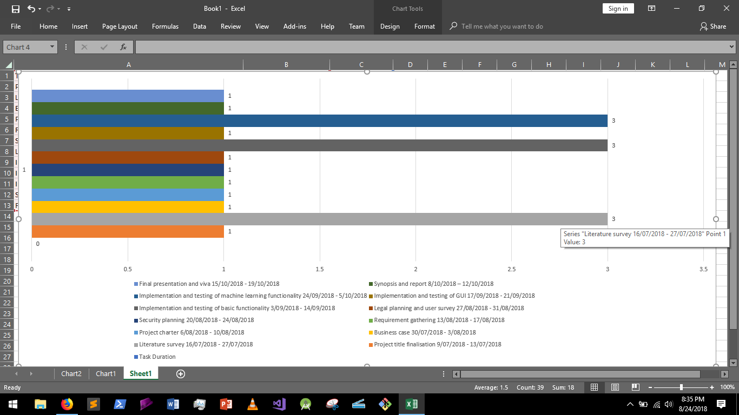

3.5 Summary

Here we summarise the analysis and planning phase of our project. The phase included scheduling, budgeting and creation of subtasks. The subtasks help us properly define our needs and features.

The analysis phase is the most crucial phase of any project. The quality of the analysis can make or break a project. Artificial intelligence presents challenges due the complexity involved in getting the balance between too much and not enough. Planning such a task is matter of finding what we really need and we don’t.

We did this phase slowly so we be could be thorough with all our requirements and plans. A slow approach also allowed us to anticipate risks.

The product backlog was divided into three phases - to do, ongoing and done.

The to do phase included - obtain insurance data, build an insurance selector, make GUI for fringe features, add a hospital finding feature, add a symptom matching feature, add an archiving feature, make a checklist database for users, obtain a fitness plan database, obtain global data for patients to compare with.

The ongoing tasks were - information catalogue building, dataset training, GUI building, procurement of more medical data for higher accuracy.

The tasks which were already done were - analysis, design, modelling, literature survey, budgeting and scheduling, feasibility analysis.

Project planning is essential to managing the scope, schedule and budget of the project. For this, we used tools such as MS Excel, MS PowerPoint, online MS project as well as various modelling tools, such as draw.io.

Stakeholder perspective is crucial to the success of this project. Part of the reason is that medical diagnosis is a highly sensitive field, and even the slightest of errors, which are evidently unavoidable in even the most sophisticated software, can lead to the patient’s condition worsening. Thus, we made it a necessity to search for user consensus before we planned for features to be built in our project.

The scheduling included a plan for the first half of the year. The plan includes - project title finalisation, literature survey, business case, project charter, requirement gathering, security planning, legal planning and user survey, implementation and testing of basic functionality, implementation and testing of GUI, implementation and testing of machine learning functionality, synopsis and report and final presentation.